Project Initialization and Planning Phase

Date | 01 October 2025
Team ID | xxxxxx
Project Name | Global Malnutrition Trends: A Power BI Analysis (1983-2019)
Maximum Marks | 3 Marks

Define Problem Statements:

This project focuses on analysing global malnutrition trends among children under five using Kaggle datasets (1983–2019).
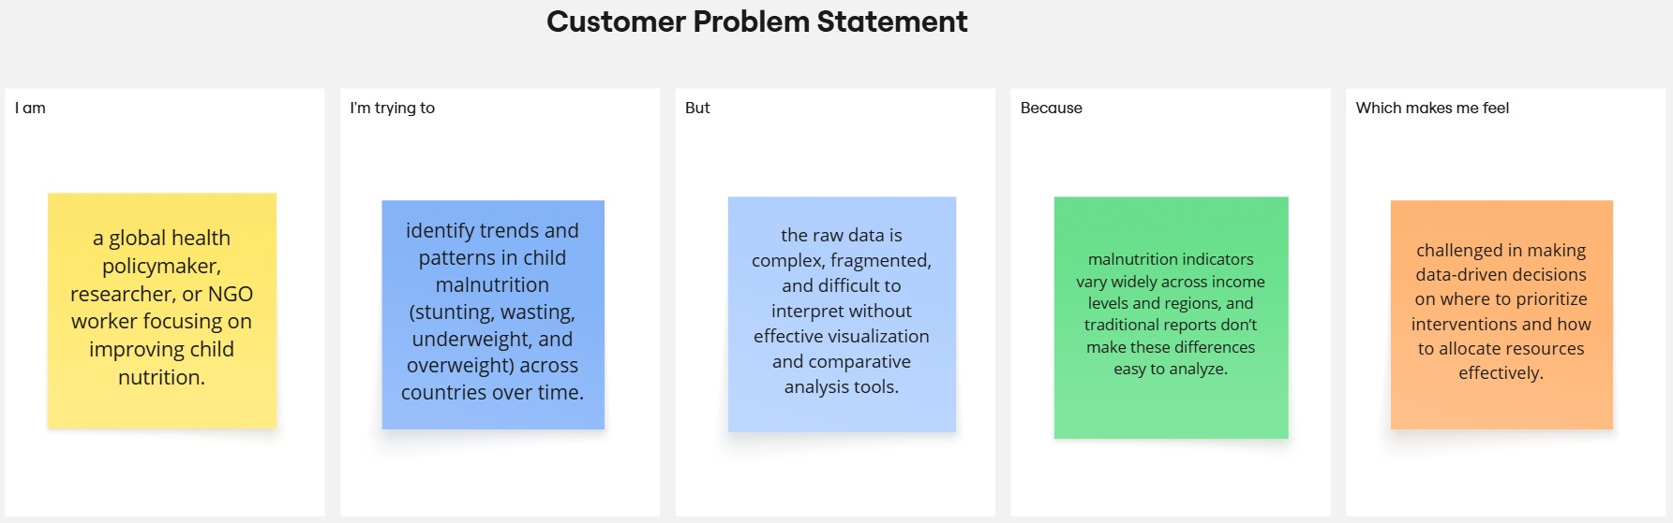
The problem statements below represent different perspectives policymakers, international organizations, and data analysts. Each statement is designed to highlight the challenges faced when dealing with malnutrition data and the need for effective visualization and insights.

Reference: https://miro.com/templates/customer-problem-statement/

Problem  Statement (PS) | I am  (Customer) | I’m trying to | But | Because | Which makes me feel
PS-1 | a global health policymaker, researcher, or NGO worker focusing on improving child nutrition. | identify trends and patterns in child malnutrition (stunting, wasting, underweight, and overweight) across countries over time. | the raw data is complex, fragmented, and difficult to interpret without effective visualization and comparative analysis tools. | malnutrition indicators vary widely across income levels and regions, and traditional reports don’t make these differences easy to analyze. | challenged in making data-driven decisions on where to prioritize interventions and how to allocate resources effectively.
PS-2 | a decision-maker in an international organization working on Sustainable Development Goals (SDG-2: Zero Hunger). | understand the correlation between a country’s income classification (low, middle, high) and the prevalence of malnutrition among children under five. | without interactive tools, it is hard to compare undernutrition vs. overnutrition trends and track progress across decades. | traditional reports lack interactivity, do not highlight country-level variations effectively, and make it difficult to pinpoint critical problem areas. | uncertain about how well current interventions are working and concerned that some high-risk groups may continue to be overlooked.

